For Immediate Release
MEDIA CONTACTS
Mack Falstein
Ofer Lugasi
AllBe1
ofer@allbe1.com
mfalstein@gmail.com
(323) 283-8731

AllBe1 - SIMPLE, COMPACT DEVICE SOLVES MULTIPLE PERSONAL SECURITY CHALLENGES

AllBe1 Debuts Multi-function, Smartphone-enabled Capsule:
Alarm, Fitness & Geo-Tracker and More...

Tel Aviv, Israel, June 23, 2015 - Leave it to the Israelis to develop the world’s first smartphone-enabled personal security guardian that performs dozens of critical security functions, all in a tiny, elegant and durable package.
AllBe1 is a reliable, affordable, all-in-one personal security guardian that can replace any number of costly devices, providing both convenience and security while it eliminates clutter and confusion.

AllBe1 can be used as a:
- Silent alarm alert
- Drawer-open detector
- Smartphone smart lock
- Motion detection
- Fitness tracker
- Child or pet tracking device
- UV monitor
- Smart button
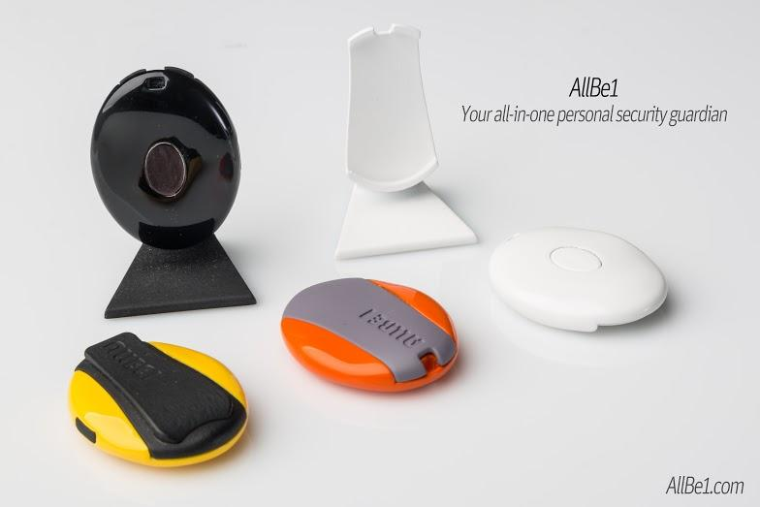

“I created AllBe1 to solve any number of personal security challenges, all in one simple, elegant package,” said Ofer Lugasi, creator of the AllBe1. “As a gadget freak, I have drawers full of single-purpose devices that prove to be unwieldy and impractical, so I don’t use them. By combining numerous different sensors with an open-platform design, AllBe1’s practical applications are limited only by the imagination.”

AllBe1 is an open source platform, enabling developers from all over the world to create new applications.

The AllBe1 team includes hardware and software developers from the private security sector. AllBe1 is a new product whose development is financed through a crowdfunding campaign on Indiegogo.

Learn more at http://igg.me/at/allbe1.
View the AllBe1 informational video here.

For information, contact:
Ofer Lugasi - founder: ofer@allbe1.com
or
Mack Falstein - PR hapiness member
Email: mfalstein@gmail.com

Website: www.allbe1.com
Social media: Facebook, Twitter, youtube
AllBe1 press kit - link

